Moose Lake Area
Fire District

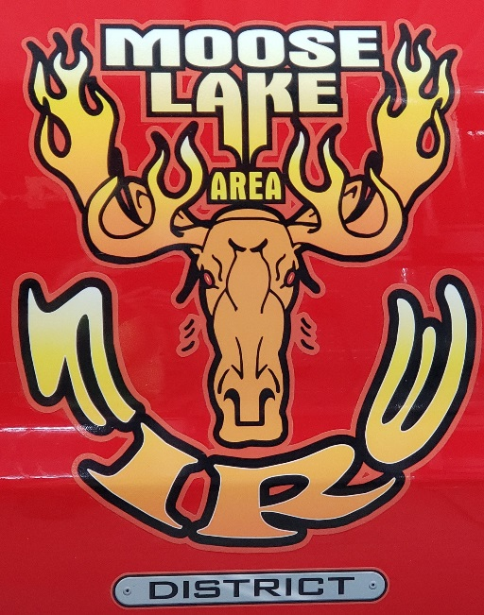

Firefighter Job Description

Firefighter - Job Description

General Purpose
Provides fire and emergency medical services for the Moose Lake Area Fire District. Firefighters are hired through the established hiring process and are approved by the Moose Lake Area fire District. These are at will volunteer positions. Firefighters have the responsibility for fire protection of life and prope1ty from hazards of fire or other hazardous environments.

Supervision Received
Works under the general guidance and supervision of Chief, Assistant Chief, Captain, and Lieutenants and also agrees to adhere to all policies and guidelines set by the Moose Lake Area Fire District.

Supervision Exercised
In the absence of superior officers on the scene, the firefighter with the most seniority shall assume command until relieved of such command by a superior officer.

Essential Emergency Response Duties and Responsibilities
- Respond to all emergency calls which may include search, rescue, fire alarms, ventilation, fire suppression, and overhaul.
- Selects, drags, lifts, and carries hose and nozzle depending on the type of fire, and correctly applies a stream of water or chemicals onto the fire.
- Positions and climbs ladders to gain access to upper levels of buildings or assist individuals from burning structures.
- Wears appropriate protective clothing and equipment, including self-contained breathing apparatus as needed.
- Able to effectively communicate both orally and written, as well as communicate with two-way communications systems.
- Operate under the Incident Command System at all types of emergency operations using established Incident Command System procedures (NIMS).

Peripheral Staff Duties
- Attends and participates in drills and trainings, attends classes in firefighting, emergency medical care, hazardous materials, and related subjects. Personnel will be required to attend trainings and meetings.
- Attends regular and assigned training sessions to maintain and upgrade firefighting skills.
- Participates in the inspection of buildings, hydrants, and other structures in fire prevention programs.
- Maintains fire equipment, apparatus, and facilities.
- Performs minor repairs to departmental equipment and/or informs appropriate officers of needed repairs.

2

- Performs general maintenance work in the upkeep of fire facilities and equipment; cleans and washes walls and floors; cares for grounds around station; makes minor repairs; washes, hang and dries hoses; washes, cleans, polishes, maintains and tests apparatus and equipment.
- Is responsible for maintaining his or hers Personal Protective Equipment (PPE) per manufactures recommendations.
- Presents programs to the community on safety and fire prevention topics.

Minimum Qualifications
- Education and Experience
  - Graduation from High School or minimum GED equivalent with no specialized training.
  - Eligible applicants shall be a U.S. citizen. Must also reside within the Moose Lake Area Fire District Primary Service Area (PSA), live within a 6-minute legal response time of the fire hall.
  - Obtain Firefighter 1 & 2 and Hazardous Materials Certifications within 2 years
  - Obtain Health Care Provider CPR Card within 1 year

Necessary Knowledge, Skills and Abilities:
  - Working knowledge of driver safety;
  - Working knowledge of first aid;
  - Ability to successfully learn the operation of the listed tools and equipment;
  - Ability to learn to apply standard firefighting, emergency aid, hazardous materials, and fire prevention techniques.
  - Ability to perform strenuous peak physical effort during emergency, training or station maintenance activities for prolonged periods of time under conditions of extreme heights, intense heat, cold or smoke;
  - Ability to act effectively in emergency and stressful situations;
  - Ability to follow verbal and written instructions;
  - Ability to communicate effectively orally and in writing;
  - Ability to establish effective working relationships with employees, other agencies and the general public;
  - Ability to meet the special requirements listed below.

Minimum Requirements
- Must be eighteen (18) years of age or older at time of hire.
- Must possess, or be able to obtain by the time of hire, a valid State of Minnesota Class D Driver' s License without record of suspension or revocation in any state;
- No felony convictions or disqualifying criminal histories. Assault, Sexual Abuse of any kind, Robbery/Theft, Embezzlement;
- Ability to read and write the English language; and
- Ability to meet Departmental physical standards.

3

Tools and Equipment Used
Fire trucks and tanker, fire aerial apparatus, fire pumps, generators, hoses and nozzles, porta powers, chop saw, ventilations saw, chain saw, auto extrication tools , SCBA, SCBA fill station and compressor, ground ladders, radio’s hand held and truck, pagers , assist EMS with defibrillator, suction devices, oxygen delivery, stair chair, cots, and other firefighting and medical equipment.

Physical Demands
The physical demands described here are representative of those that must be met by an employee to successfully perform the essential functions of this job. Reasonable accommodations may be made to enable individuals with disabilities to perform the essential functions.

While performing the duties of this job, the employee is frequently required to stand; walk; use hands to handle or operate objects, tools, or controls; and reach with hands and arms. The employee is occasionally required to sit; climb or balance; stoop, kneel, crouch, or crawl; talk or hear; and taste or smell.

The employee must frequently lift and/or move up to 10 pounds and occasionally lift and/or move up to 100 pounds. Specific vision abilities required by this job include close vision, distance vision, color vision, peripheral vision, depth perception, and the ability to adjust focus.

Work is performed primarily in office, vehicle and outdoor settings, in all weather conditions, including temperature extremes, during day and night. Work is often performed in emergency and stressful situations. Individual is exposed to hazards associated while rendering emergency medical assistance, including smoke, noxious odors, fumes, chemicals, liquid chemicals, solvents and oils.

The employee occasionally works near moving mechanical parts and in high, precarious places and is occasionally exposed to wet and/or humid conditions, fumes or airborne particles, toxic or caustic chemicals, risk of electrical shock, and vibration.

The noise level in the work environment is usually quiet in office settings, and loud at an emergency scene.

Selection Guidelines
All applications received will be reviewed for experience, education, and qualifications. Applicants will be offered an interview if the fire department is currently seeking members. Selection will be made by the District Board. Conditional offers will be given to those applicants selected pending a pre-employment screening including a drug screen, physical agility test, and background check.

New hire firefighters will be subject to completion of a probationary period. The examples of duties are intended only as illustrations of the various types of work performed. The omission of specific statements of duties does not exclude them from the position if the work is similar, related or a logical assignment to the position. The job description does not constitute an employment agreement between the employer and the employee and is subject to change by the employer as the needs of the employer and requirements of the job change.

4

•
Best time to contact you at home is:
_ _ : am/pm
Are you over 18 years of age?
Yes
Have you ever filed an application with us before?
Yes
If Yes, give date
_
No
No
Have you ever been employed with us before?
If Yes, give date _
Yes
No
Do any of your friends or relatives, other than spouse, work here? ?
Yes
lf Yes, who-
Are you currently employed?
No

Yes
No
Do you have any physical limitations or health conditions which may limit your ability to perform the job applied for?

Moose Lake Area Fire District
Application for Employment

Position(s) Applied For: |  |  | I Date of Application:
How Did You Learn About Us?  _ Current Employee - Who? | Advertisement | _ | Relative _ Inquiry Friend Other_ _ _ _ _ _ _ _ _ _ _

Last Name |  |  | First Name | Middle Name
Address | Number |  | Street | City
State |  | Zip | Home Telephone  ( ) | Mobile Telephone  ( )

Are you prevented from lawfully becoming employed in this country
because of Visa or Immigration Status?  Proof of citizenship or immigration status will be required upon employment | Yes | No
Date available for work: | I | I

Employment Experience
Start with your present or last job and list your Employment history. Include any job-related military service assignments and volunteer activities. You may exclude organizations which indicate race, color, religion, gender, national origin, disabilities or other protected status.

Employer | Dates Employed |  | Work Performed
 | From MM/YY | To MM/YY
Address
Telephone Number(s) | Hourly Rate/Salary
 | Starting | Final
Job Title ISupervisor
Reason for Leaving

Employer | Dates Employed |  | Work Performed
 | From  MM/YY | To  MMIYY
Address
Telephone Number(s) | Hourly Rate/Salary
 | Starting | Final
Job Title I Supervisor
Reason for Leaving

Please provide any pertinent past work experience with BLS ambulance service or health care related field.
Employer: | Job title: | Certification:
Employer: | Job title: | Certification:
Please explain duties performed.

Name and City of School

Elementary School

High School

Undergraduate College

Graduate Professional

Other
(i.e. Technical College)

Course of Study
Years
Completed Diploma/Degree

Additional Information
List any current Fire or EMS licenses - EMSRBINREMT (EMR, EMT, Paramedic), CPR FF/&2 with expiration dates
Specialized Skills/Equipment Operated
State any additional information that you.feel may be helpful to us in considering your application.

Please submit the Names of three persons not related to you, whom you have known for at least one year.

 | Name | Address | Occupation | Phone
Note to Applicants: A COPY OF THE JOB DESCRIPTION FOR WHICH YOU ARE APPLYING SHOULD ACCOMPANY THIS APPLICATION. IF IT DOES, ANSWER THE FOLLOWING QUESTION ONLY AFTER REVIEWING THAT JOB DESCRIPTION, IF IT DOES NOT, DO NOT ANSWER THE FOLLOWING QUESTION.

Are you capable of performing in a reasonable manner, with or without reasonable accommodation, the activities involved in the job or occupation for which you have applied? A review of the activities involved in such a job or occupation has been given.
YES
NO
Applicant's Statement

Applicant is required to sign the application to receive consideration. By virtue of your signature the applicant certifies and acknowledges the following:

- That answers given herein are true and complete.

- Investigation of all statements and references contained in this application for employment as may be necessary in arriving at an employment decision is hereby authorized.

- I hereby understand and acknowledge that, unless otherwise defined by applicable law, any employment relationship with the Moose Lake Area Fire District Fire is of an “at will" nature, which means that the Employee may resign at any time and the Employer may discharge Employee at any time with or without cause. It is further understood that this "at will" employment relationship may not be changed by any written document or by conduct unless such change is specifically acknowledged in writing and signed by the Moose Lake Fire District Board.

- That the Moose Lake Area Fire District is hereby authorized to make contact with my present employer(s), but that such contact shall not be made unless I am a finalist for the position for which l am applying.

- ln the event of employment, I understand that false or misleading information given in my application or interview(s) may result in discharge. I understand, also, that I am required to abide by all rules and regulations of the Moose Lake Area Fire District.

Signature of Applicant Date

